PSHE
Summary Document 2023

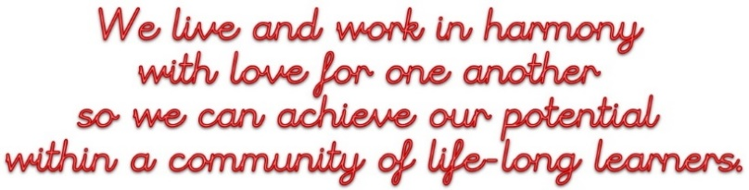
The whole experience of PSHE is in line with our vision (above). In particular, this is evident in our sense of community and the way our pupils and staff interact, our tolerance and respect for others and our knowledge of how to take steps to ensure our personal safety.

The PSHE Big Ideas are:
My Friendships | My Health | My Body | My Safety | My Community
Threads and Neurons in the PSHE Curriculum
Descriptor | Evidence
An ambitious curriculum that gives all learners the knowledge and cultural capital they need | We recognise the importance of the PSHE curriculum and deliver it in line with the units devised by the Cambridgeshire PSHE Service. We have marked the importance and identity of the subject by keeping the personalised book plates to go onto the front of each book.
Coherently sequenced planning | In PSHE, we revisit key themes during alternate years, building upon knowledge and skills already learnt. We have looked at coverage of the units throughout the year and the content of the new statutory framework and adjusted our curriculum accordingly. For example, we have removed the financial capability unit and added the online safety units.
Skills to support employment | The increasing importance of online safety in the PSHE curriculum is a very useful reminder to the children of the importance of lifelong learning on this subject, whether for home or work. The skills of tolerance, empathy and respect for others will also be invaluable in the workplace.
Holding the same high ambitions for all pupils, with the curriculum tailored to support those of high need | PSHE lends itself well to a range of different abilities. There is sometimes no written recording necessary or a response could be a drawing or contribution to discussion. Working as part of a group is often a key part of the learning objective in a lesson and this helps to adapt to the different strengths of our pupils.
Explore the full curriculum, including cross-curricular links | There are many cross-curricular links with the Science curriculum when teaching about our bodies, puberty and human reproduction. There are cross-curricular links with the Computing curriculum with the new online safety units. There are cross –curricular links with themes taught and discussed in assembly, British Values and of course PSHE is a vital strand of our wider safeguarding culture.

Delivering the PSHE Curriculum
Descriptor | Evidence
High level of teachers’ subject knowledge and quality CPD | We have looked at the content of the statutory guidance during CPD meetings. We have also had Cathy Murphy from the Cambs PSHE service to deliver some CPD to the whole staff on community and diversity.
Effective delivery by teaching staff | Visits from the PSHE link governor to carry out a book scrutiny and to talk to some of the pupils about their thoughts on PSHE.
Effective assessment and rapid feedback for pupils that also informs planning | The smiley face self- assessment sheets provide good feedback to pupils so they can track what they have learnt within each unit although they are not used consistently throughout the school. There is perhaps more flexibility within PSHE than in other subjects. Teachers are able to adapt and change the PSHE curriculum to suit the specific needs of their cohort. For example, focusing strongly on building friendships as a response to a specific need in a particular class. Teacher assessment might not focus on academic performance in class but on emotional literacy shown in the playground.
Teaching of the subject is designed to enable pupils to remember learning in the long term and integrate new concepts | Revisiting the same topics during alternate years helps to embed knowledge and skills. Marking anti-bullying week with more activities such as taking part in Odd Socks Day and inviting outside providers to run workshops (generously funded by the PTA), will help to make the key message memorable.
Assessment is informative, useful and smart | Assessment is an ongoing discussion. Some classes are using the pupils self -assessment smiley face pages at the start and end of units. We need to discuss assessment in PSHE alongside assessment expectations in other foundation subjects.
The environment and other resources support learning effectively | We are continuing with a programme of renewal in our library and classroom books, funded by the PTA so that pupils recognise themselves in our literature.
Reading is integrated within this subject | Many of the PSHE units use children’s fiction as starting points for discussion or as a way to draw out emotions or actions of a fictional character. We have purchased many of the texts during the past two years.

Pupils achieve their potential in PSHE
Descriptor | Evidence
Learners develop detailed knowledge and skills, which is evident in their attainment and progress | Evidence that shows a range of skills, data from assessments
Learners are ready for the next stage of their education | Most children will transfer to Sawston Village College and we know that the curriculum is taught there in a one hour lesson each fortnight with the 3 themes of health and wellbeing, relationships and sex education and living in the wider world. However the skills the children have learnt at Shelford- for example identifying strategies to calm feelings of anger or to build friendships, to stay safe online or to be united against bullying will be useful at this next stage of their education.
Learners apply good reading skills in this subject | The children do not frequently need to read a large amount of text in this subject.

Specific Links to our Specialisms, Awards and Accreditations
Specialism, Award or Accreditation | Links with this Subject
RE graded ‘Excellent’ by SIAMS, Church School Status | The teaching of tolerance and respect towards those who might seem different to us, perhaps because of their religious beliefs.
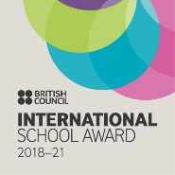
International School Award for outstanding development of the international dimension of the curriculum
Primary Science Quality Mark Award | Healthy lifestyles, drug education, SRE teaching about our bodies, the changes in puberty and human reproduction.
School Games Silver Award | Healthy lifestyles
Commitment to professional development, research, mentoring and coaching. | Attendance at PSHE subject leader briefings and CPD led by Cambridgeshire PSHE service.
Mu
Music Mark
Commitment to prioritising music throughout and beyond the curriculum. us
M
M

