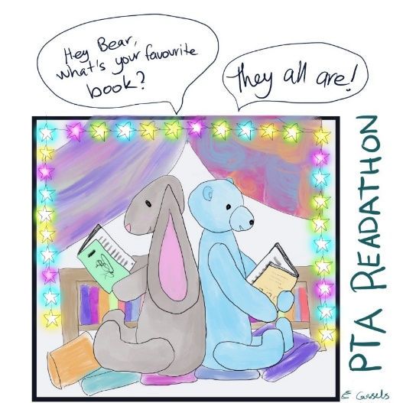

Gt and Lt Shelford Primary School
Readathon Challenge 2023

Name: _____________________________ Year: _____

I am raising money for Shelford school by taking part in a Readathon over the Easter holidays.
Between 1st-16th April, my goal is to read ____ books/chapters OR read for ____ minutes per day.
Name of sponsor | Address | Amount pledged  (per book/minute or  flat rate) | Total due | Collected Yes/No

I read _____ books and raised a total of £_____ for Shelford school.
I read for _____ minutes and raised a total of £_____ for Shelford school.
Please transfer total sponsorship money directly into PTA account: Shelford School PTA, Sort code: 30-91-74 and Account number: 01248038. Please write ‘Readathon’ as the reference.

