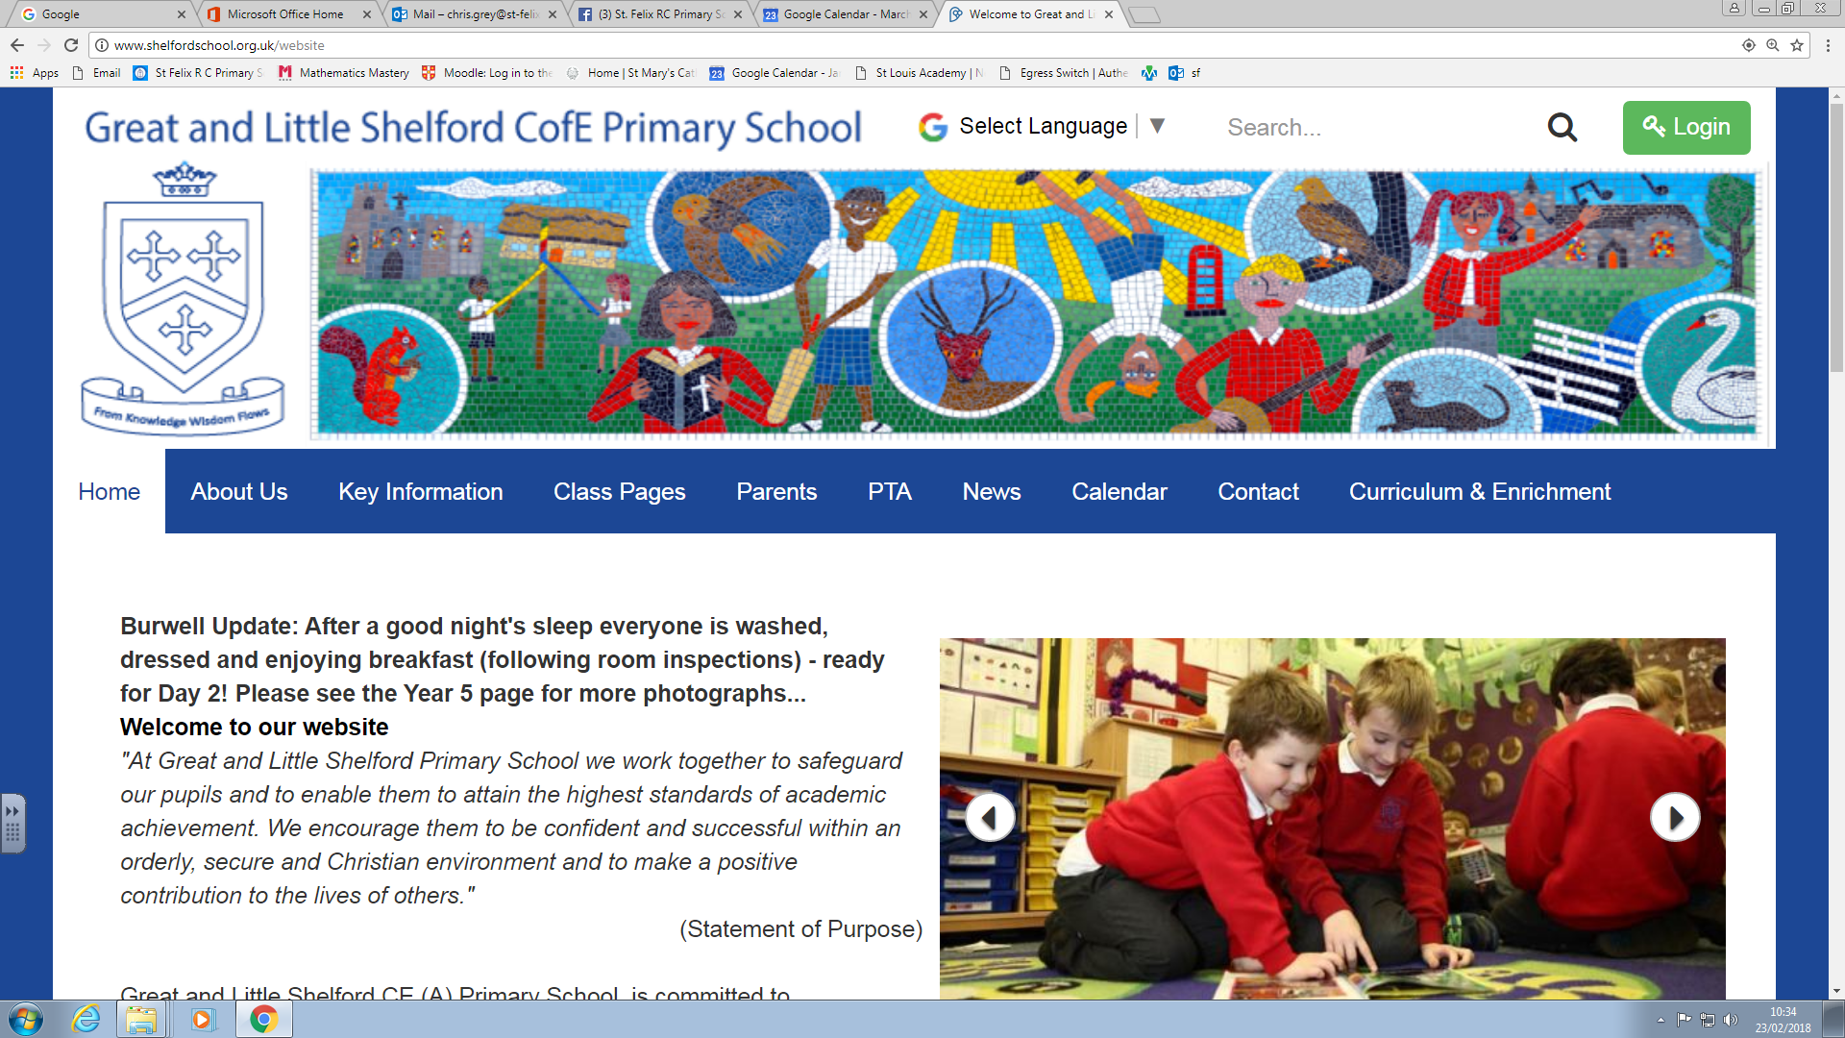

**Modern Foreign Language (French)**

Summary Document 2023

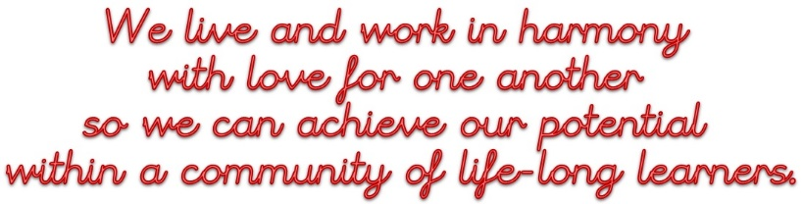

The whole experience of MFL is in line with our vision (above). In particular, this is evident in how pupils work collaboratively both in the classroom and in correspondence to pen pals; pupils achieve their potential as evidenced in results and staff continue their own learning by adapting teaching in line with recent teaching and learning research.

**The MFL Big Ideas are:**

|  |  |  |  |  |
| --- | --- | --- | --- | --- |
| Phonics | Grammar | Vocabulary | Cultural Capital | Songs, Stories & Rhymes |

**Threads and Neurons in the MFL Curriculum**

|  |  |
| --- | --- |
| **Descriptor** | **Evidence** |
| An ambitious curriculum that gives **all** learners the knowledge and cultural capital they need | Pupils are encouraged to work things out for themselves, work in pairs and small groups sharing knowledge, and to speak aloud, when possible, thereby building confidence. Pronunciation, memory, pattern finding, sentence building, autonomy, performance and creativity are the concepts at the heart of our French curriculum (Rachel Hawkes SoW). There are many opportunities to develop cultural capital through learning about traditions and festivals across the year. Pupils also access this through participating in the pen pal scheme with CIPEC International school and participating in enrichment activities. We hope that we will be able to recommence an annual visit from pupils at our partner school in Verneuil-en-Halatte in France.  The Rachel Hawkes SoW is designed to introduce pupils to learning a modern foreign language. It introduces pupils to the customs, festival and way of life in France, whilst also giving them the skills to develop their growing competency in language learning. The scheme is topic based, but still with some emphasis on phonics, grammar, and vocabulary. Cultural elements feature throughout the programme e.g. in a lesson about ‘La fête des Rois’ at Christmas. |
| Coherently sequenced planning | We use the national curriculum as well as the Rachel Hawkes SoW for French as the basis for our curriculum planning to ensure the coverage of skills as well as objectives and content. Curriculum planning is in two phases (long-term and detailed medium-term). The long-term plan maps the French topics studied in each term. We plan the topics in French so that they build upon prior learning. Children of all abilities have the opportunity to develop their skills and knowledge in each unit and, through planned progression built into the scheme of work, we offer them an increasing challenge as they move up the school. We use the Rachel Hawkes website, which enables individual teachers to access a wide range of high-quality planning ideas, resources and guidance for the delivery of French lessons.  The scheme repeats key phonics, vocabulary and grammar learning at various points. The repetition of vocabulary and content really helps embed learning but should not overload pupils. Teachers have the autonomy to vary the pace according to the needs of the class. There is also significant emphasis on pronunciation. The PPT resources have both video and audio files of a French speaker pronouncing the phonemes and vocabulary as they are introduced. This is great for non-speakers of the language when teaching the lessons. |
| Skills to support employment | Pupils at Shelford School receive a broad and balanced curriculum and in French, learning is purposeful and knowledge rich. Our French lessons allow our pupils to become confident, resilient and more culturally aware. In line with our vision, we encourage our pupils to be life-long learners and our French lessons enable our pupils to be ready for the modern workplace. |
| Holding the same high ambitions for all pupils, with the curriculum tailored to support those of high need | There is a wide range of different abilities in all classes and we provide suitable learning opportunities for all pupils by matching the challenge of the task to the ability of the pupil:   * setting common tasks which are open-ended and can have a variety of responses; * setting tasks of increasing difficulty, some pupils not completing all tasks whereby all pupils are encouraged to challenge themselves at the appropriate level but are not limited; * sometimes grouping pupils by ability (but not always as there are also advantages to grouping pupils in mixed abilities) and setting different tasks to each ability group; * providing resources of different complexity and providing support materials according to the ability of the child; * using teaching assistants to support the work of individual pupils or groups where required.   Research shows that EAL pupils can have lots of success in language learning. This has been a trend for our school and this will continue to be monitored this academic year and going forward. |
| Explore the full curriculum, including cross-curricular links | Our whole school curriculum document makes clear our topic and cross-curricular links with particular emphasis on cultural capital and global learning. There are several enrichment activities such as our pen pal scheme and twinned town partnership visits. The school is also host to a popular French Club, provided by La Jolie Ronde, and held after school (one KS1 and another KS2 club). |

**Delivering the MFL Curriculum**

|  |  |
| --- | --- |
| **Descriptor** | **Evidence** |
| High level of teachers’ subject knowledge and quality CPD | Learning walks are conducted annually by the subject leader and link governor. Prior to this, a staff questionnaire is distributed via Google Form and designed to give the subject leader a picture of teaching and learning in the classrooms and to give an opportunity for teachers to feedback suggestions on what works well and what they would like to work better. The subject leader attends termly MFL hub meetings to keep up to date with current research and practice, and also holds a subscription to the Association of Language Learning (ALL). ALL’s aim is to support language teachers with resources, advice and training. Opportunities for CPD are shared with staff delivering French. |
| Effective delivery by teaching staff | Monitoring of lessons through learning walks by subject leader and link governor. Book scrutiny. Questionnaires for pupils as well as staff. Pupil interviews. |
| Effective assessment and rapid feedback for pupils that also informs planning | Teachers can assess speaking and listening in French and give immediate feedback to pupils (AfL, ‘live marking’, oral feedback). Misconceptions are identified and clarified as they arise. Lessons recap previous learning. Mini plenaries are used to measure and act on progress within lessons.  Each pupil will be assessed termly using the progression of skills document for the relevant year group and these are then transferred onto Target Tracker. The previous subject leader revised these documents so that the RH descriptors align with Target Tracker statements. The SoW includes a ‘Quiz’ at the end of each term which teachers are encouraged to use to make assessments. |
| Teaching of the subject is designed to enable pupils to remember learning in the long term and integrate new concepts | French lessons are structured into five main sections; an introduction and recap of vocabulary, speaking, listening, reading and writing. The teaching provides an appropriate balance of spoken and written language. Themes, skills and concepts are revisited within different topics to help pupils hold onto knowledge. We are in the Process of designing ‘Knowledge Organisers’ for pupils to revisit key phonics, grammar and vocabulary. We recognise that French learning is unfortunately impacted by the fact it is only taught once per week, so where possible we incorporate French language into the daily routine, e.g. registration, greetings, asking common questions, commenting on the weather, counting etc. |
| Assessment is informative, useful and smart | Pupils are assessed against the progression of skills document each term and this is transferred to Target Tracker. Within this, children working towards, at and above age-related expectations are identified and tracked enabling teachers to identify gaps in learning and areas for consolidation or further challenge. |
| The environment and other resources support learning effectively | Lesson plans and resources are taken from the Rachel Hawkes SoW. All PPT presentations and lesson worksheets are accessible online and can be adapted by teachers to meet the needs of all learners as necessary. Resources are monitored regularly, with pupils and teaching staff involved in the process of deciding what we need to purchase. All classes now have access to French dictionaries and have an age-appropriate selection of fiction books for reading. Lessons take place in pupils’ usual classrooms with ‘Knowledge Organisers’ being used, where available, for quick reference.  The subject page on the school website is frequently updated and features links to a number of websites and apps for children to access to consolidate or extend their learning if they so wish. |
| Reading is integrated within this subject | There are several opportunities for reading the language written down on screen, on worksheets and on display. All classes have a selection of French texts on their bookshelves. Links are made to particular books within the planning documents. There is an emphasis on using the correct pronunciation and intonation, and the Rachel Hawkes audio files with PPT resources help exemplify this, to both pupils and teachers/HLTAs who may be less confident. |

**Pupils achieve their potential in MFL**

|  |  |
| --- | --- |
| **Descriptor** | **Evidence** |
| Learners develop detailed knowledge and skills, which is evident in their attainment and progress | Whilst there was a dip in attainment in the academic year 21-22 (due to a series of partial school closures and lack of prioritisation of foundation subjects) there has since been consistent improvement. |
| Learners are ready for the next stage of their education | It is celebrated that children learning an additional language can connect with other cultures, making them more open-minded and tolerant of diversity.  French lessons at Shelford, in line with our vision, allow pupils to become confident, resilient and more culturally aware. We want to work alongside our main feeder secondary school, Sawston Village College School as our pupils will continue to learn French as a foreign language in Key Stage 3 (some will learn Spanish and in Year 8, pupils have the opportunity to learn both). We will make reference to the ALL ‘Transition Toolkit’ as we recognise the importance of primary colleagues knowing what comes next and likewise for secondary colleagues knowing what has already been taught. Having reached out to SVC, there is not much they are able to offer us in terms of support, at the moment. We are keen to reestablish our links with them and so the Subject leader will continue to pursue the relationship as appropriate. |
| Learners apply good reading skills in this subject | Pupils exercise reading skills through using French dictionaries and accessing French texts in the classroom as well as written text on worksheets and onscreen. The RH scheme also includes video and audio files so that correct pronunciation can be exemplified. |

|  |  |
| --- | --- |
| **Specific Links to our Specialisms, Awards and Accreditations** | |
| **Specialism, Award or Accreditation** | **Links with this Subject** |
|  | Reaccreditation of the International School Award for outstanding development of the international dimension of the curriculum.  International Partnership Schools, including Jules Ferry (Verneuil-en-Halatte, Shelford’s twinned town in France) – exchange programme hosted by the Twinning Association. Continued partnership with CIPEC International School in France, who we now run a successful pen pal scheme with. |
|  | Pearson World Changer Awards – ‘Runner Up in the Languages Category’  *‘The judges were inspired by the children’s achievements and commitment to make a positive difference in the world.’* |
|  | La Jolie Ronde French Club  Operating at school since 2018, running two after school clubs (KS1 and KS2). |
|  | As part of a cluster partnership with a secondary school in Norwich and two schools in Morocco (a primary and a secondary), funding was won in June 2021 to support an ongoing partnership as well as whole school CPD for global learning (this took place in October 2022 and was delivered by RISC). As Morocco is a Francophone country, our Year 5 class have set up a pen pal scheme with Secteur Scolaire Annour, a primary school in the Atlas mountains. |
|  | Picture News Impact Award July 2021  Picture News Advocate School April 2022 |