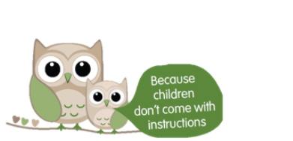

Raising Teens

Wednesdays 6:30-8:30pm

Starts 15th January for 10 weeks

**(Not on during Feb Half Term)**

Being a parent is one of the hardest but also one of the most rewarding jobs. Unfortunately teenagers don’t come with an instruction manual…

The Raising Teens programme is aimed at offering parents of children aged 10-17 years a supportive and informal environment, in which to gain information, knowledge and skills around parenting.

To book your place call 01954 286012 or email

Districtearlyhelpteam.southcambs@cambridgeshire.gov.uk

**At Melbourn Village College**

The Moor, Melbourn, Royston, SG8 6EF

Get directions to this location on Google Maps.