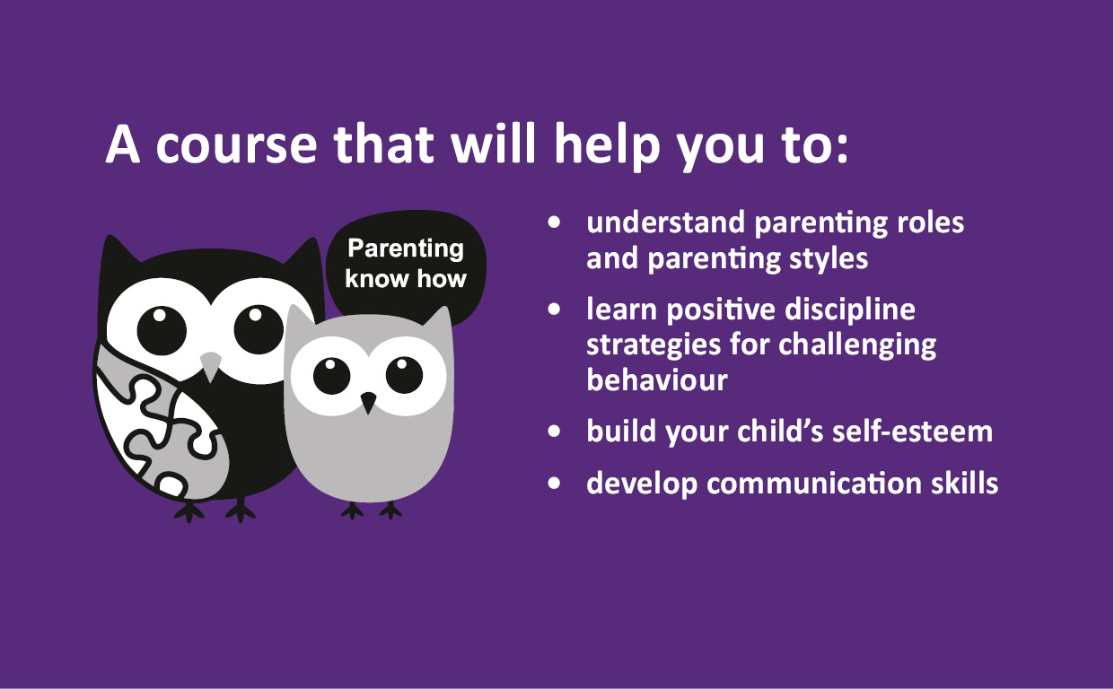

Raising Children

Mondays 6:30-8:30pm

Starts 13th January for 10 weeks

**(Not on during Feb Half Term) For parents of children up to 12**

Raising Children is suitable for all parents, from those who just want to learn more about their child's development to the parent who needs a bit more support in understanding their child's behaviour.

To book your place call 01954 286012 or email

Districtearlyhelpteam.southcambs@cambridgeshire.gov.uk

**At Northstowe Community Wing**

(On same site as Pathfinder School) CB24 1AA