Class | Autumn 1
Class | Identity
Linking to the school’s vision, we aspire for all members to achieve their potential as individuals, while showing love for one another. Understanding that we are all different but all special means that we can live and work in harmony.
R | Marvelous Me  Identity and belonging
Y1 | Shelford Stars  Identity and belonging, my story so far
Y2 | The Great Fire of London  Identity of our country
Y3 | What occurred in 1066?  Identity of our country
Y4 | Who were the Romans and how did they change Britain?  Identity of our country and culture
Y5 | Catalyst - World War II  Events that changed the identity of our country
Y6 | HMS Beagle – Why did it go where it went?  The story of human and animal identity
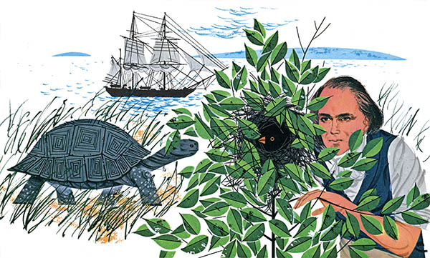
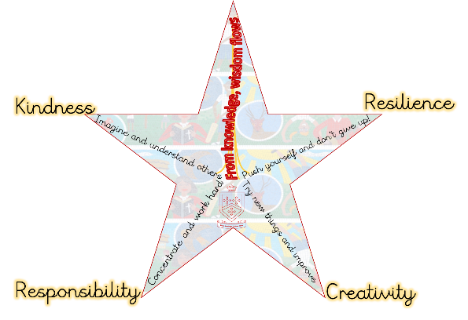
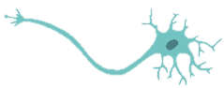
English links:
Darwin’s Dragons
Moth – narrative poem
Maths:
Place Value. Fractions, Four Operations
HMS Beagle – Why did it go where it went?
The story of human and animal identity

Art: Observational sketching inspired by Darwin’s animals
We will also be learning…
- PSHE – Rights & Responsibilities
- PE – Tag Rugby
- French – Weather
- Computing – Communication & Networks
- Music: Journeys
Science: Evolution & Inheritance
Great and Little Shelford
Geography: Voyage of HMS Beagle, focus on South America
RE: Creation vs Science. Conflicting or Complementary?
Neurons
- Prior Learning – Y3 Rocks
- Future Learning – Genetics & Evolution (KS3 curriculum)

